Project Title: NEXUS AI – Intelligent Research Workspace & Admin Control
(Basic HTML, Hyperlink and Commenting code)

- Client-side (minimum 5 screenshot of webpages)

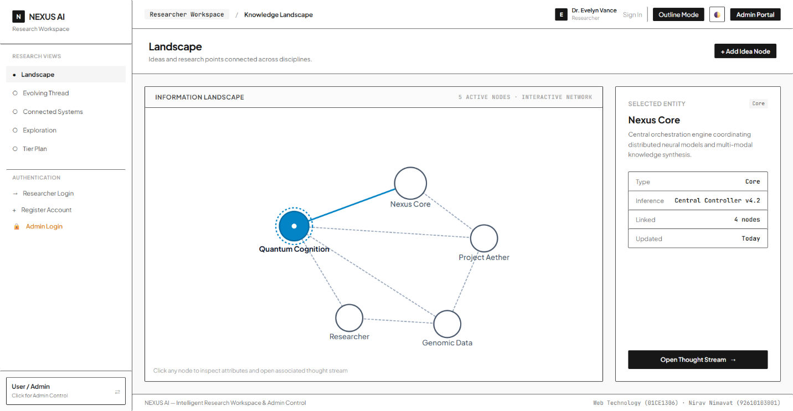

fig. 1.1 Landscape screen

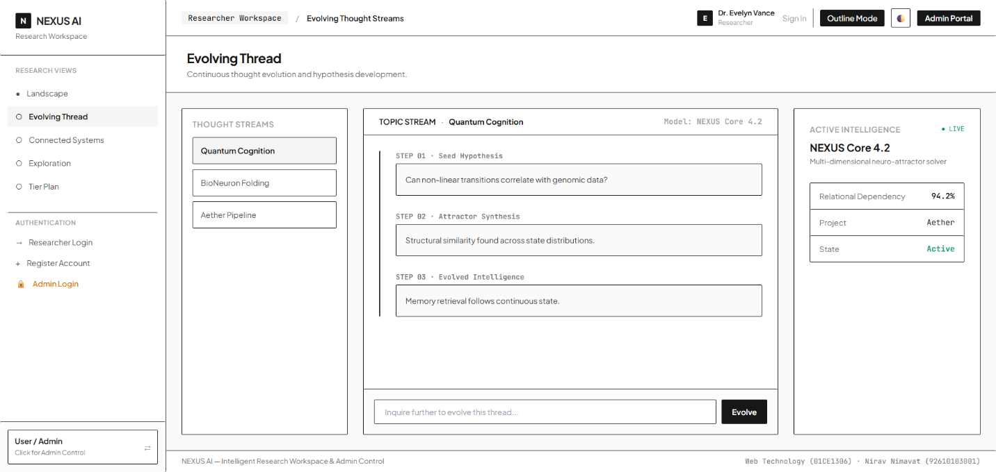

fig. 1.2 Evolving Thread screen

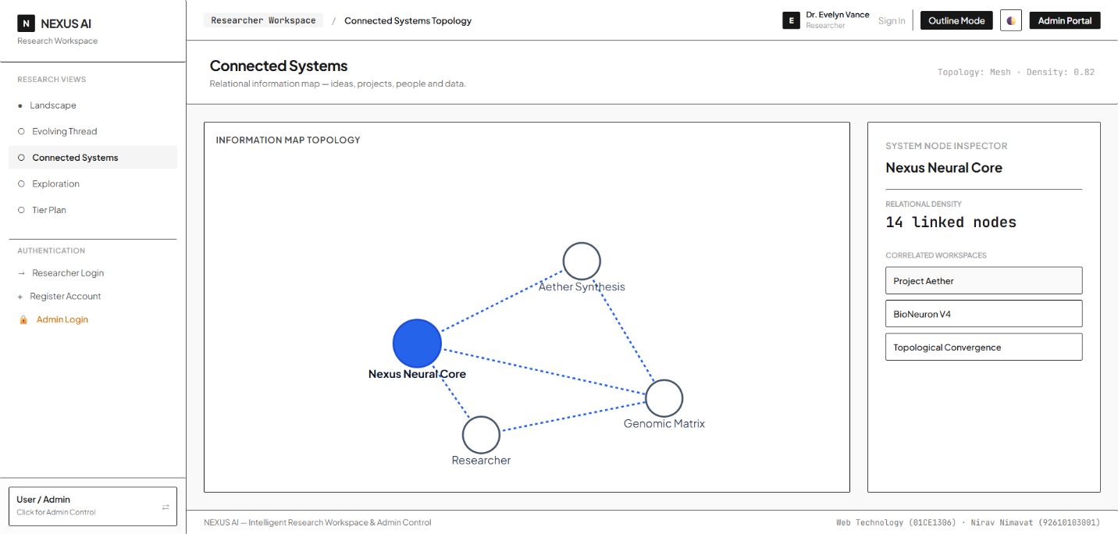

fig. 1.3 Connected Systems screen

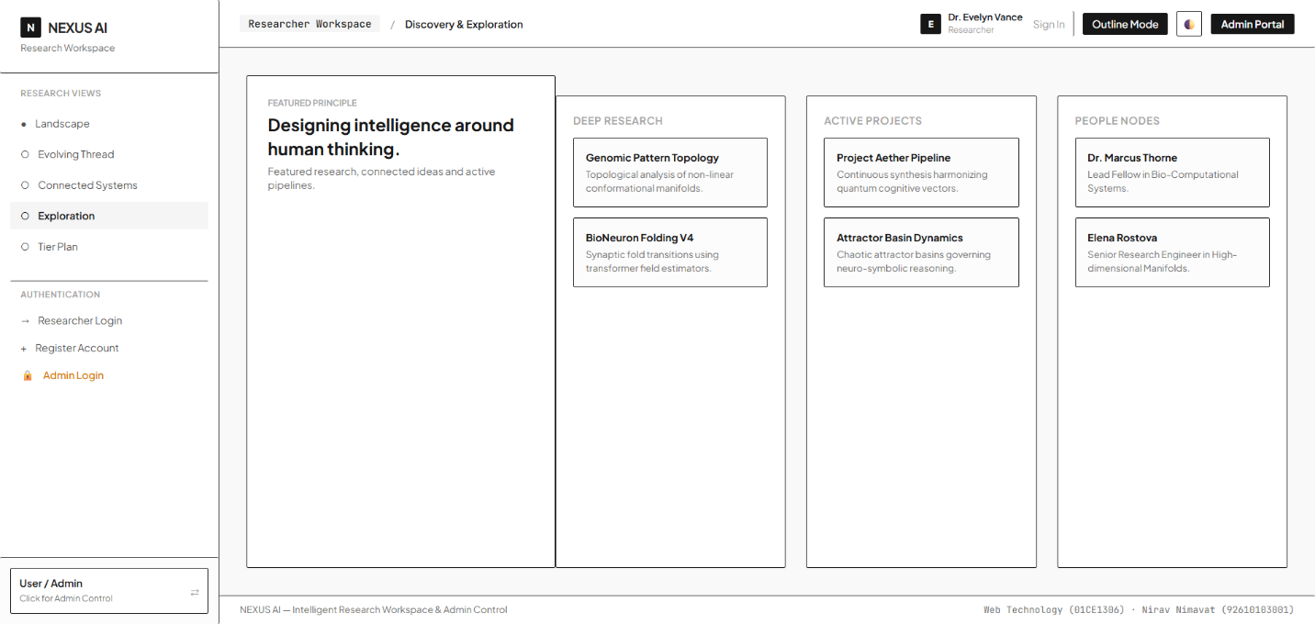

fig. 1.4 Exploration screen

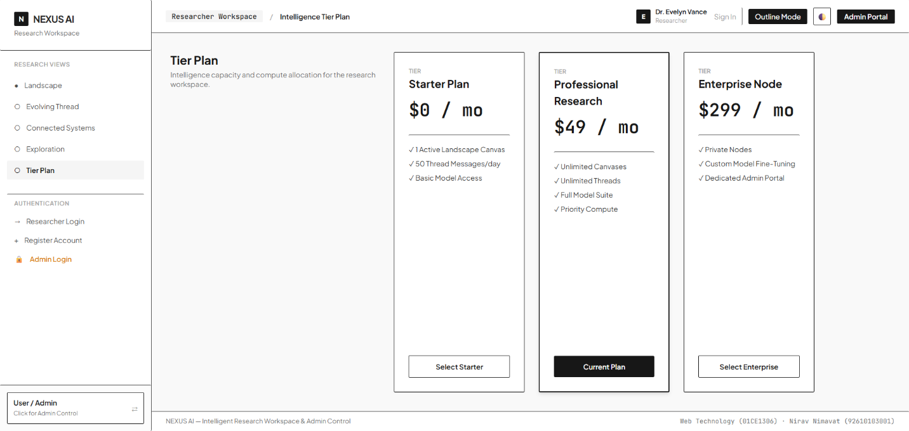

fig. 1.5 Tier Plan screen

